Game design doc

Stage 1 use forearm pronation and supination to track a ripple in the water.

Once tracked for long enough raise arm and lower arm to cast rod

To reel in the fish the player must match the actions which are appearing on the screen for example matching finger positions / hand gestures or moving arms in some way.

Once enough actions have been performed successfully the fish is caught and added either to the players total weight or the players shared total weight with their partner.

A game loop for this process would look like this:  
  
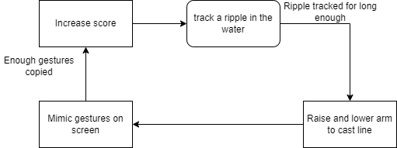

Example hand gestures

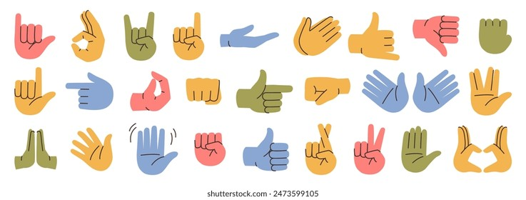

Example arm movements

